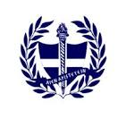

HELLENIC SWIMMERS WHO WENT TO MALAWI FOR
REGION 5 CANA SWIMMING

PLEASE MAY THE MEDAL WINNERS COME AND SEE MRS SHEARING AT BREAKTIME ON MONDAY 16 JANUARY (ALL AT THE SAME TIME) FOR A PHOTO WITH THEIR MEDALS.

